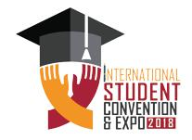
CENTRE, ISLAMABAD

TH
-13

TH

DECEMBER
2018, | ISLAMABAD

INTERNATIONAL STUDENT CONVENTION & EXPO 2018

POSTER COMPETITION

Name

ID #

Phone #

PHOTO

PAK CHINA FRIENDSHIP

CENTRE, ISLAMABAD

