11 | TH
 | -13
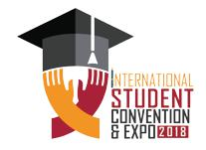

TH

DECEMBER
2018, | ISLAMABAD

INTERNATIONAL STUDENT CONVENTION & EXPO 2018

SHORT FILM FESTIVAL

Name

ID #

Phone #

PHOTO

PAK CHINA FRIENDSHIP

CENTRE, ISLAMABAD

